Used JavaScript functions to populate collections. To increase query performance, used B-Tree (range) and geospatial indexing. Ran aggregated queries to return structures exclusive of individual documents. Used MongoDB’s version of MapReduce to fetch distinct digit counts for phone numbers in an extensively large dataset.

Q1.

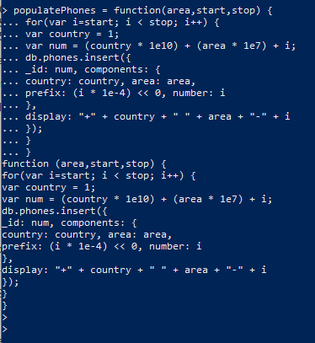

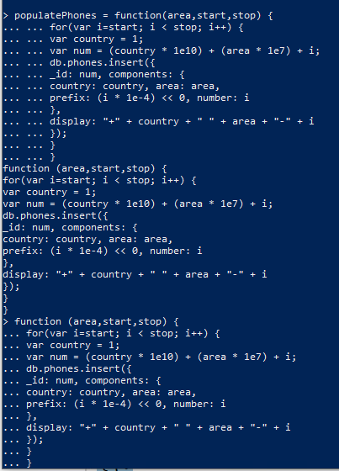



Q2.

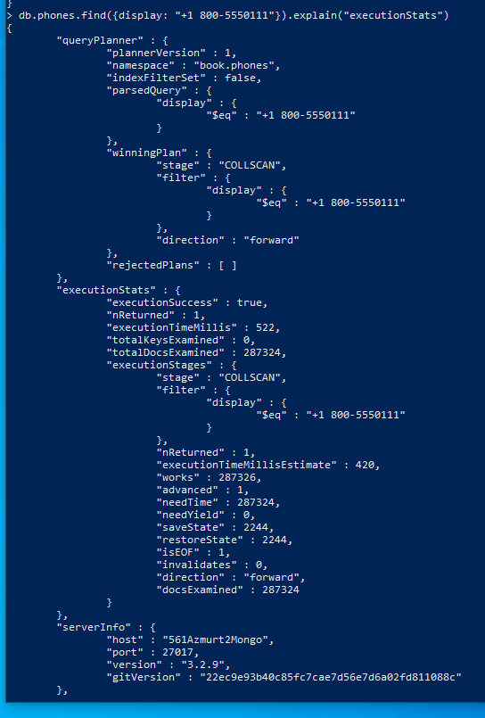

winningPlan stage: COLLSCAN

Execution Time: 522ms

Creating the Index again:

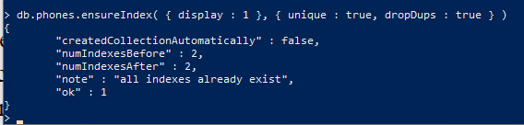

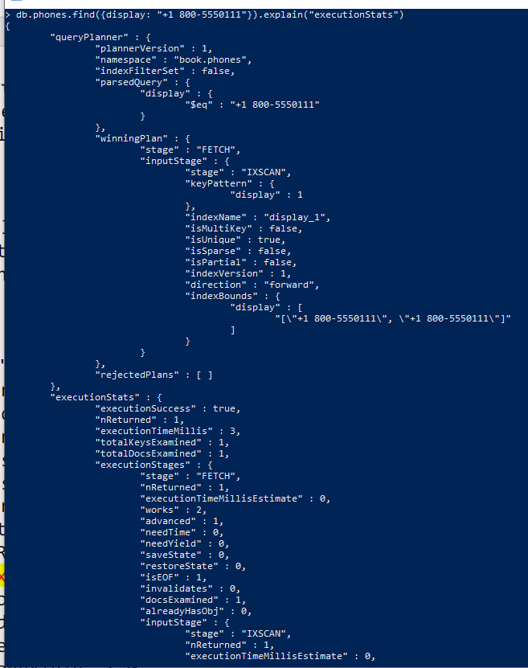

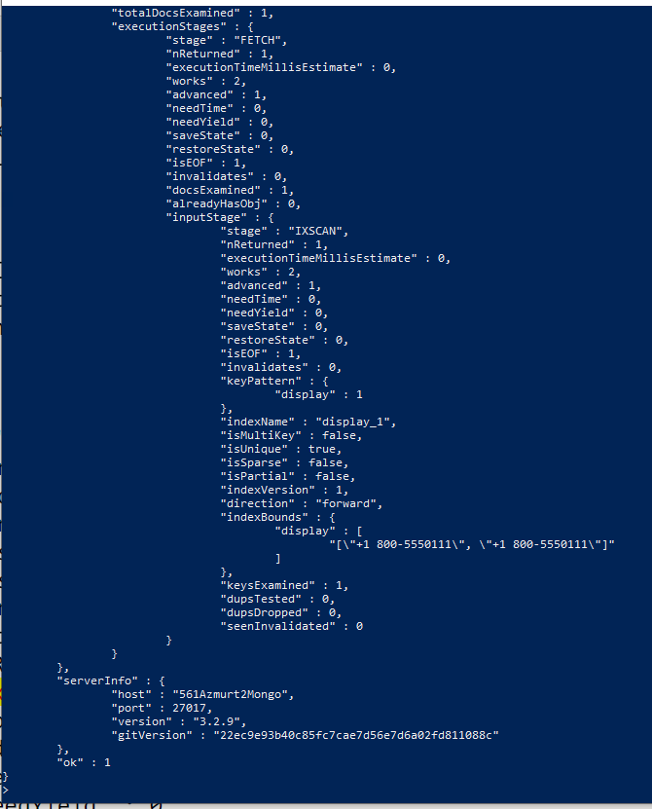

**Explanation:** The execution time has decreased to 0 ms for the IXSCAN stage. MongoDB is using the tree to retrieve the value, it isn’t performing a full collection scan. Also, since it is now a unique lookup, the number of scanned objects is now 1. The one run with the index is faster.

Q4.

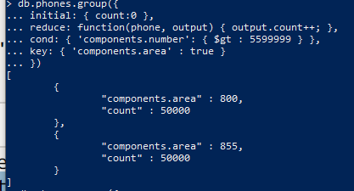

Q5.

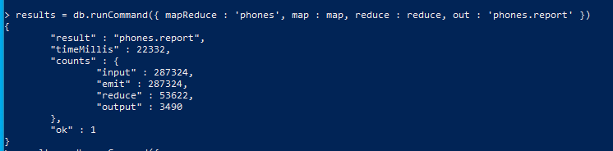

Q6.

